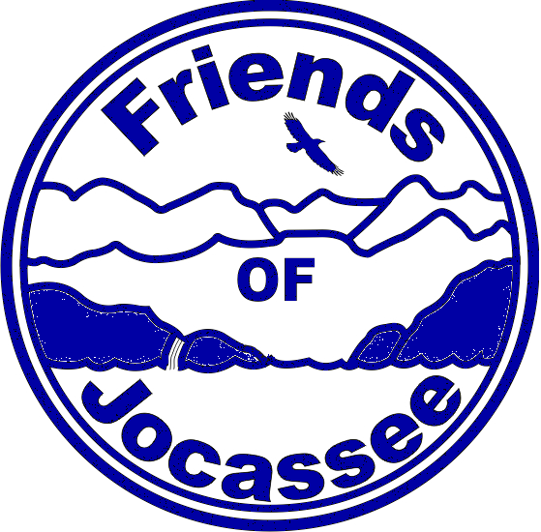
Friends of Jocassee
PO Box 621
Salem, SC 29676

To whom it may concern,

The Friends of Jocassee is pleased to announce its Educational Scholarship Award Program for up to $1,000. The Friends of Jocassee will consider proposals from individuals and organizations that further its mission, which is to preserve, promote and protect the Jocassee Gorges. This mission strives to further greater awareness and understanding of the natural, historical, and cultural significance of the lake and the surrounding area. A proposal must include a concise narrative that describes the location, objective and expected outcome of the project as well as a detailed budget. Application templates are provided for this. Projects must be completed in one year or less. Application deadline is April 1.

After the project is complete, recipients are required:
- To submit a detailed expense report and a written project report.
- Present a brief presentation at one of our FOJ events or a poster regarding that project.

Please contact us for more information.

Sincerely,

Friends of Jocassee, Inc

Friends of Jocassee
PO Box 621
Salem, SC 29676
friendsofjocassee@gmail.com

